|  |  |  |  |  |  |  |  |  |  |
| --- | --- | --- | --- | --- | --- | --- | --- | --- | --- |
|  |  |  | **CL117** | | |  |  | **LAB 11** |  |
|  | I |  |  |  |  |  |  |  |
|  | **INTRODUCTION** | | | | |  |
|  |  |  | **Introduction to Communication and Computer Networks** |  |
|  |  |  |  |  |  |  |  |  |
|  | **TO ICT** | | | | |  |
|  |  |  |  |  |
|  | | | | | | |  | |  |
|   **NATIONAL UNIVERSITY OF COMPUTER AND EMERGING SCIENCES** | | | | | | | | |  |

**Introduction to Communication and Computer Networks**

In the modern age of information and technology, communication and computer networks have become the backbone of our connected world. These networks play a pivotal role in enabling us to share information, access resources, and communicate seamlessly, both within local environments and on a global scale. This introduction serves as a stepping stone into the fascinating realm of communication and computer networks, exploring their significance, components, and fundamental concepts.

**What is Internet?**

The internet is a global network of interconnected computers and devices that allows for the exchange of information and communication through various protocols and technologies.

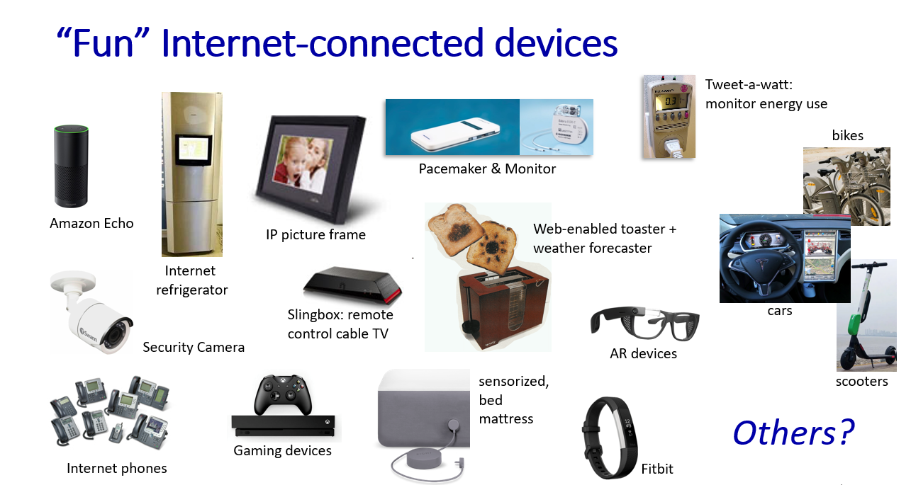

**What is a Protocol?**

A protocol is a set of rules and conventions that dictate how data is transmitted and received in a communication system. It ensures that different devices and systems can understand and interact with each other effectively. Protocols are essential for various communication domains, such as networking and the internet, and they define aspects like data format, connection establishment, and error handling procedures. Common examples include Internet Protocol (IP), Transmission Control Protocol (TCP), and Hypertext Transfer Protocol (HTTP).

**Search Engine**

* **Search Engine:** A search engine is a kind of website through which users can search the content available on the Internet.
* Then the search engine looks through its index for relevant web pages and displays them in the form of a list.
* Some of the popular ones are: **Google**, **Bing**, **Yahoo**, **Duck duck go**, **Baidu**, etc.

**Three main components of the Search engine**

* **Crawler**: program that It regularly scans the websites automatically for URLs, keywords, and links in order to discover the new updates.
* **Index**: the Crawler continuously scans the websites, it develops an index of URLs, links and keywords to make the search results more effective
* **Search Algorithm:** It is working by searching for the index and finding for the most suitable webpages by matching keywords that are searched by the users.

**Web Browser**

* Web Browser: The web browser is an example of application software that is developed to retrieve and view the information from web pages or HTML files present on the web servers
* Microsoft’s internet explorer, Google Chrome, Mozilla Firefox,  
  Opera and Apple safari.

**Email (Electronic mail)**

is a communication method that uses electronic devices to deliver messages across computer networks.

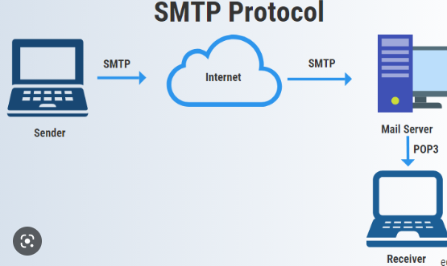

**Why we need IT Security**

* Reducing the risk of data breaches and attacks in IT systems.
* Applying security controls to prevent unauthorized access to sensitive information.
* Preventing disruption of services, e.g., denial-of-service attacks. Protecting IT systems and networks from exploitation by outsiders

**What is CIA?**

* Three most important concept of security are CIA: CIA stands for Confidentiality, Integrity and Availability

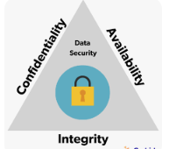

**Key Security concept (CIA)**

* Confidentiality measures are designed to prevent sensitive information from unauthorized access attempts. Such as photo, videos, transaction etc.
* Integrity means that data or information in your system is maintained so that it is not modified or deleted by unauthorized parties.
* Availability means that systems and data are available to individuals when they need it under any circumstances, including power outages or natural disasters.

**Threat -** Represents Potential security harm to an Asset

**Vulnerabilities**

* Corrupt: loss of integrity
* Leaky (loss of confidentiality)
* Unavailability: (Loss of availability)

**Network Topology**

Network topology refers to how various nodes, devices, and connections on your network are physically or logically arranged in relation to each other. Think of your network as a city, and the topology as the road map. Just as there are many ways to arrange and maintain a city—such as making sure the avenues and boulevards can facilitate passage between the parts of town getting the most traffic—there are several ways to arrange a network. Each has advantages and disadvantages and depending on the needs of your company, certain arrangements can give you a greater degree of connectivity and security.

**Types of Network Topology**

**Star Topology**

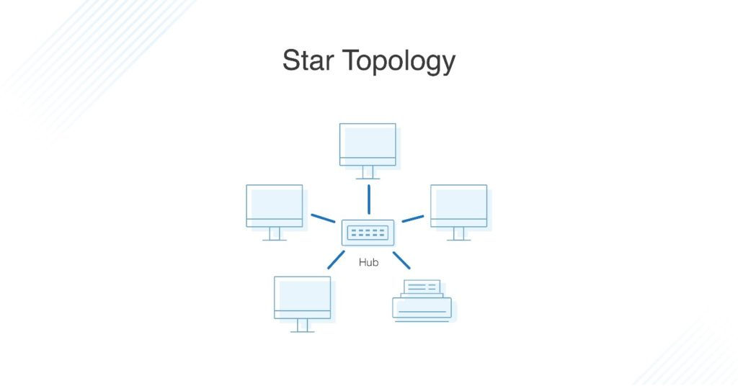

A star topology, the most common network topology, is laid out so every node in the network is directly connected to one central hub via coaxial, twisted-pair, or fiber-optic cable. Acting as a server, this central node manages data transmission—as information sent from any node on the network has to pass through the central one to reach its destination—and functions as a repeater, which helps prevent data loss.

**Bus Topology**

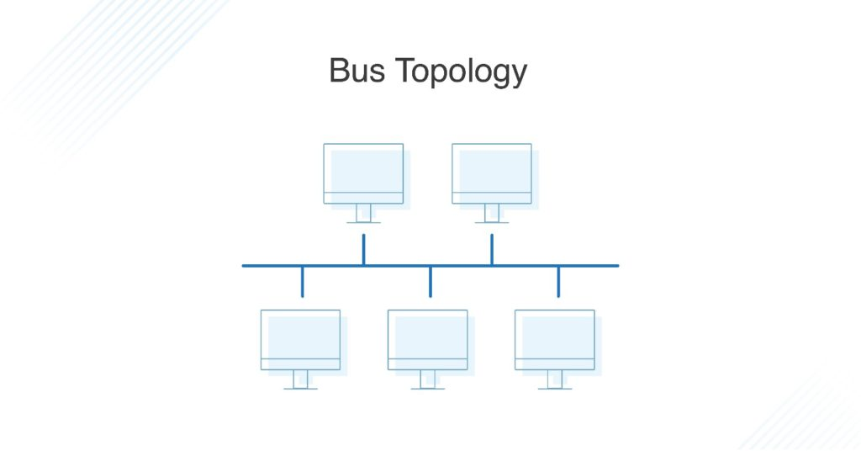

A Bus Topology is a network type in which every computer and network device is connected to a single cable. It is bi-directional. It is a multi-point connection and a non-robust topology because if the backbone fails the topology crashes.

**Ring Topology**

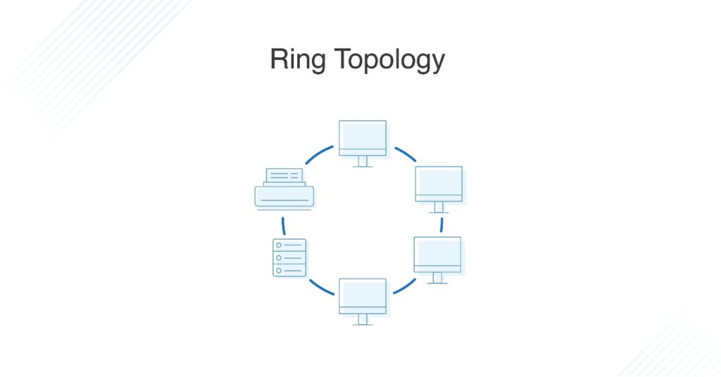

Ring topology is where nodes are arranged in a circle (or ring). The data can travel through the ring network in either one direction or both directions, with each device having exactly two neighbors.

**Mesh Topology**

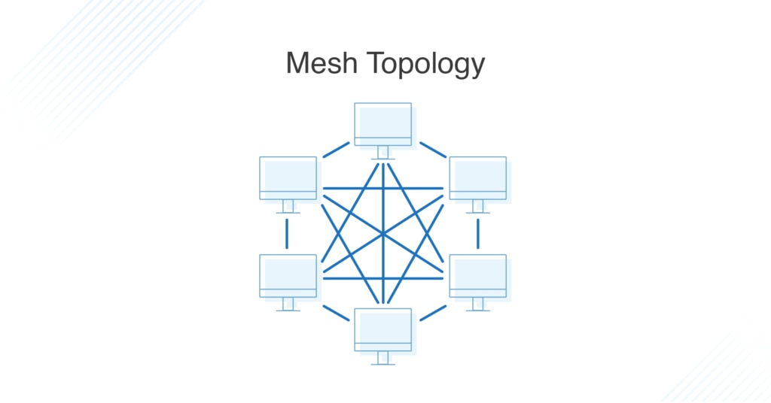

A mesh topology is an intricate and elaborate structure of point-to-point connections where the nodes are interconnected. Mesh networks can be full or partial mesh. Partial mesh topologies are mostly interconnected, with a few nodes with only two or three connections, while full-mesh topologies are fully interconnected.

**IP Address**

An IP address, which stands for Internet Protocol address, is a numerical label assigned to each device (such as a computer, smartphone, or networked printer) participating in a computer network that uses the Internet Protocol for communication. It serves two main functions:

1. **Host or Network Identification**: IP addresses are used to uniquely identify a device or a network on the internet. They are similar to street addresses for mail delivery but for digital data packets. An IP address provides a way for data to be sent to and received from specific devices or networks.
2. **Routing**: IP addresses play a crucial role in routing data across the internet. Routers and other networking equipment use these addresses to determine the best path for data to travel from the source to the destination.

Type “ipconfig” in Command Prompt to display the IP configuration for all network interfaces on a Windows computer.

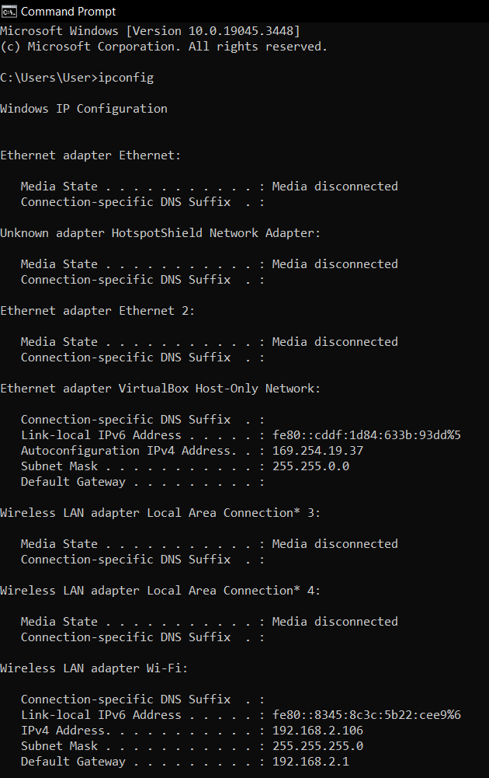

**What is a subnet?**

A subnet (short for "subnetwork") is a logical division of an IP network into smaller, more manageable, and isolated networks. Subnetting is a technique used in IP networking to improve network efficiency, security, and organization. It involves dividing a larger IP network into smaller, more manageable segments, known as subnets, by allocating a portion of the original network's IP address space to each subnet.

**What is a Router?**

A router in a computer network is a device that forwards data between different networks. It plays a key role in connecting devices and ensuring efficient data transmission.

**What is a Switch?**   
A switch in computer networks is a hardware device that connects multiple devices, such as computers, printers, and servers, within a local area network (LAN). It uses MAC addresses to forward data only to the device for which the data is intended, making network communication more efficient and secure compared to traditional hubs.

An **IP address class** is a categorical division of internet protocol addresses in IPv4-based routing. Separate IP classes are used for different types of networks. Some are used for public internet-accessible IPs and subnets, that is, those networks behind a router (as in classes A, B and C).



**Cisco Packet Tracer**

Cisco Packet Tracer is a network simulation and visualization tool developed by Cisco Systems. Packet Tracer allows users to create virtual networks and experiment with various network configurations without the need for physical networking equipment.

**Setting up a Basic Network on Cisco Packet Tracer**

Open Cisco Packet Tracer

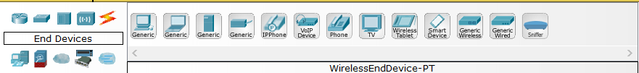

In bottom left portion we can pick end devices, routers, switches, hubs, and wires etc.

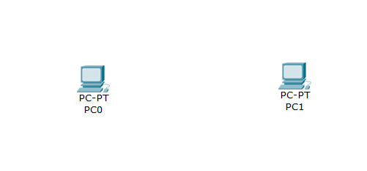

We have picked generic two PCs to set up a network connection between them

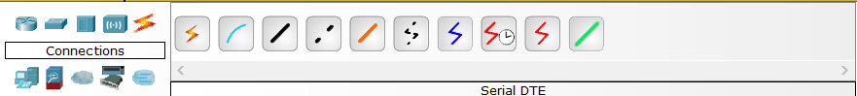

Click on the connections tab and pick Copper Cross over cable

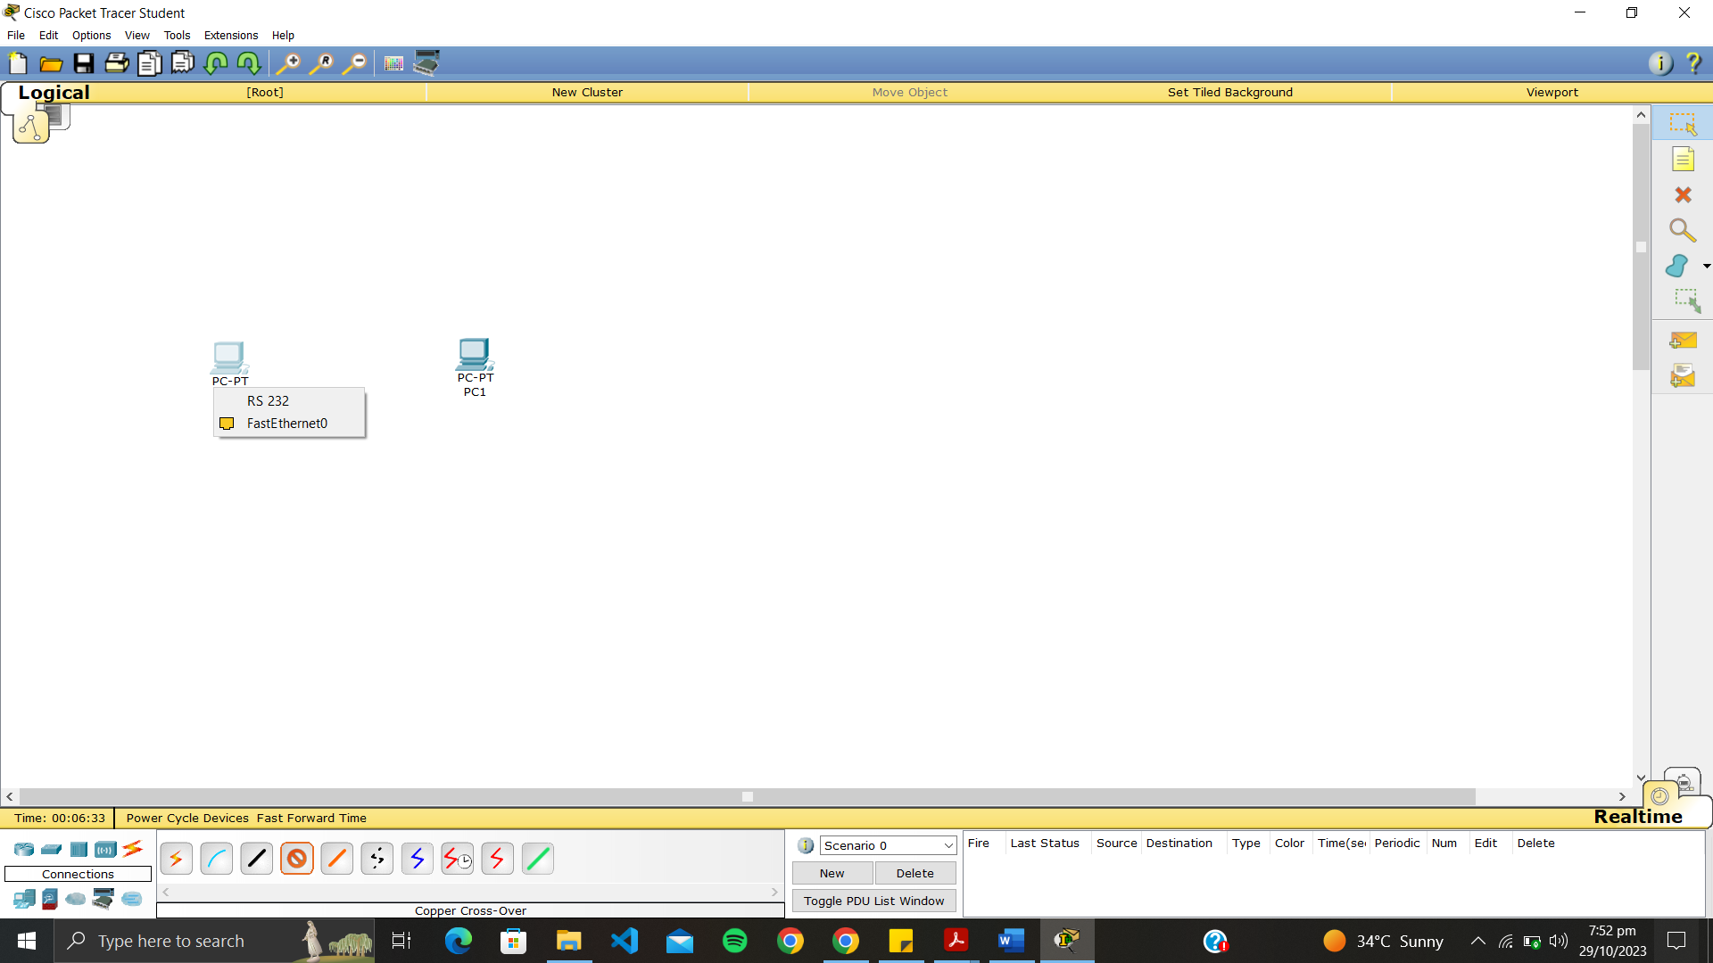

After picking the cable click on the PC and Select FastEthernet0

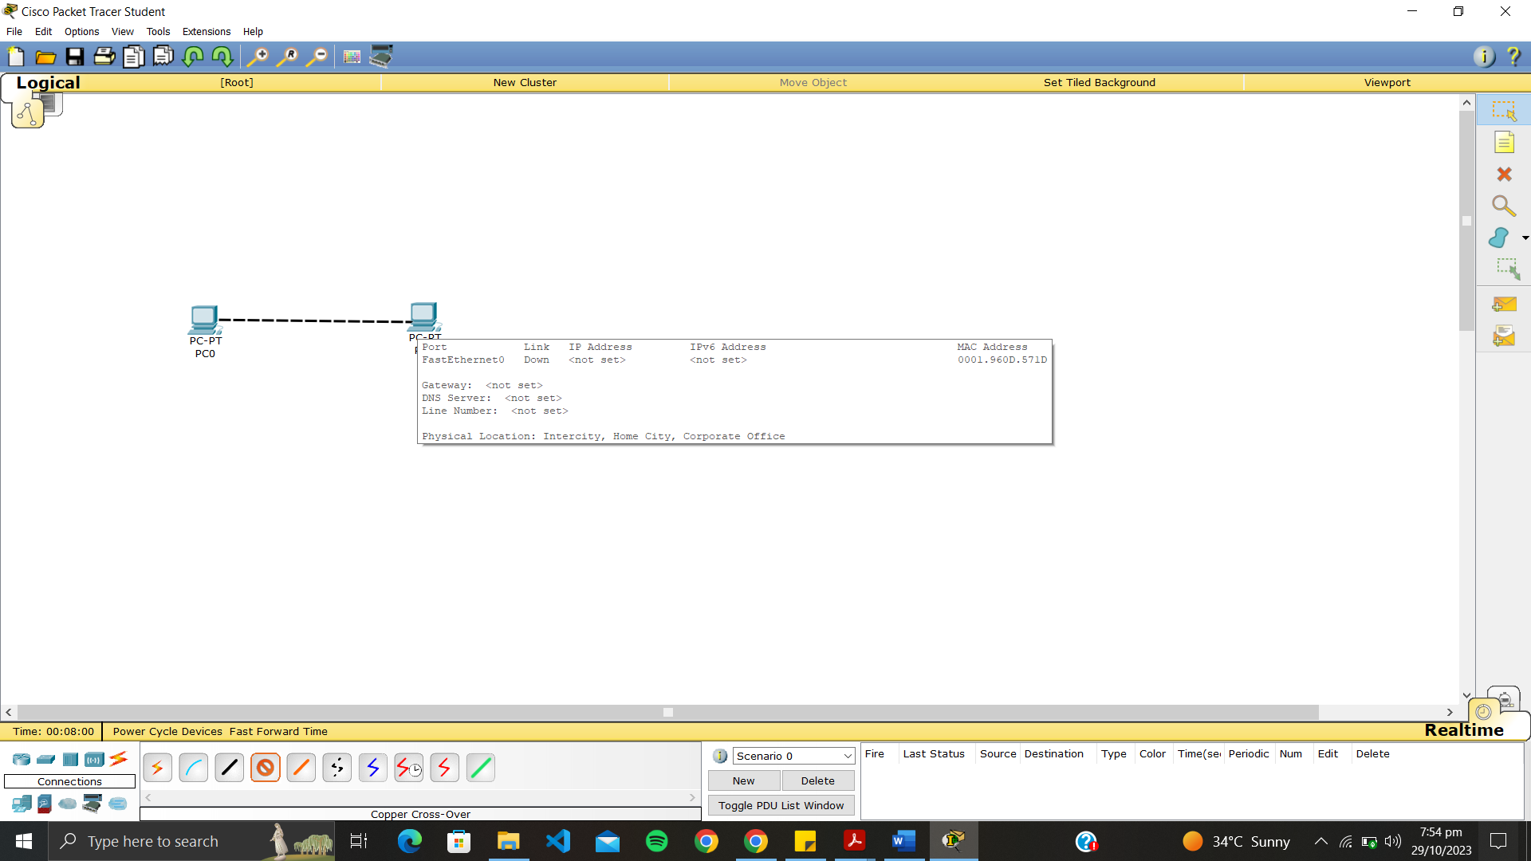

Drag the cable towards the other PC

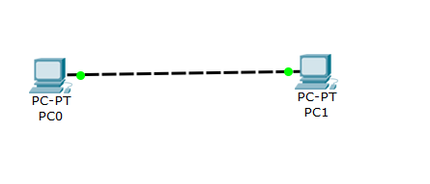

Wires Connected!

Now we will assign IP Addresses to our Systems

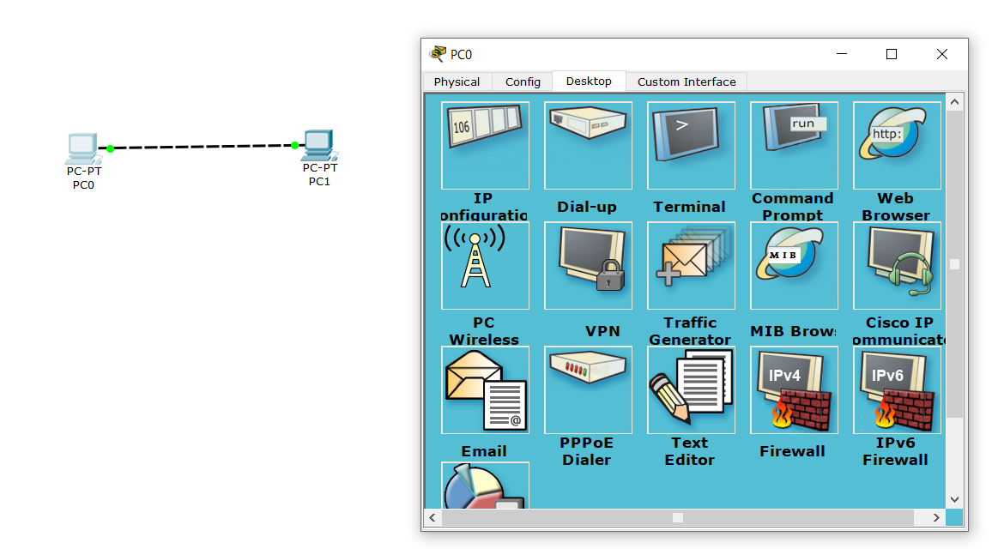

Click on PC0 and it will open a Menu with various configuration Options in Desktop Tab. Pick IP Configuration.

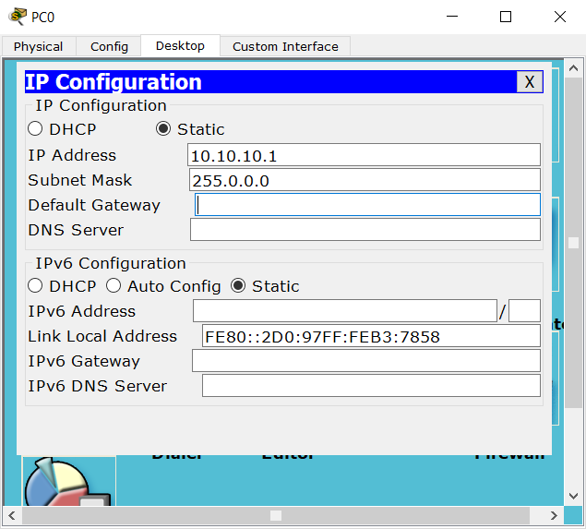

Add the following IP Address and Subnet Mask for PC0

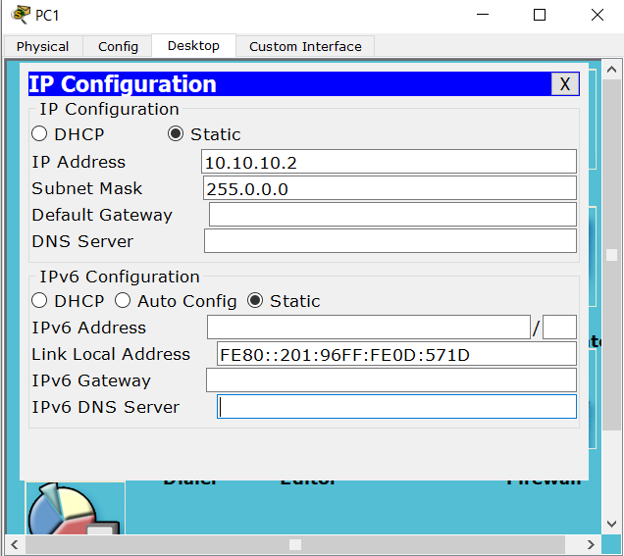

Repeat the same steps for PC1 with a different IP Address.

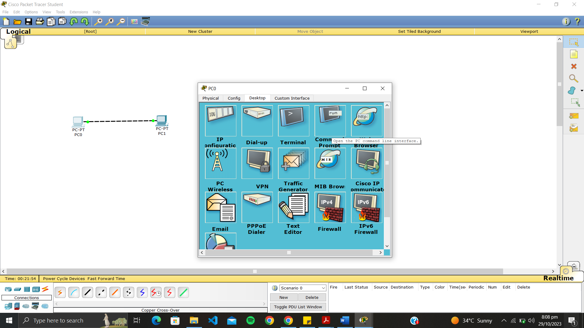

Open the menu for PC0 again and this time click on Command Prompt

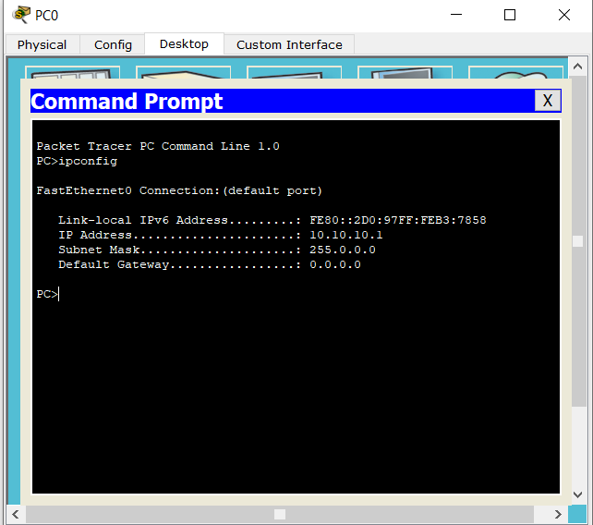

Type “ipconfig”. We can see that the IP has been assigned. You can check it again for PC1

Now we will ping PC1 from PC0. When you run the "ping" command, it sends a series of ICMP (Internet Control Message Protocol) echo requests to the specified target. The target, in response, should send back ICMP echo replies. This process helps you determine whether the connection is established and how quickly it responds.

The output of the "ping" command typically includes information such as the number of packets sent, received, lost, the round-trip time (ping time) in milliseconds, and some statistics about the connection quality.

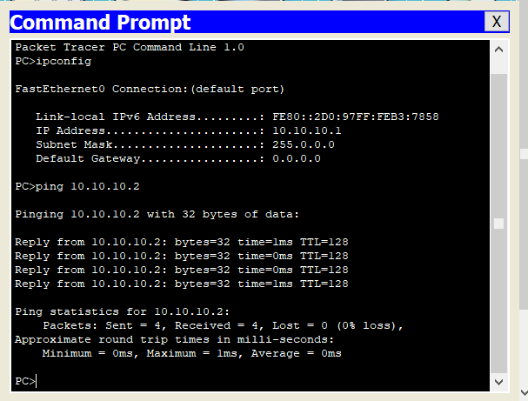

“ping 10.10.10.2” sent 4 packets and received 4 packets which shows that Connection is established from PC0 to PC1 AND PC1 is reachable from PC0.

**Lab Tasks**

* Provide real-world examples that illustrate the practical application of the principles of Confidentiality, Integrity, and Availability (CIA)
* Explain Differences between Star and Mesh Topology.
* Take two PCs, connect them with suitable wire Assign them a different IP addresses and check their connectivity by using PING command. Add Screenshot of each step in a Word Document